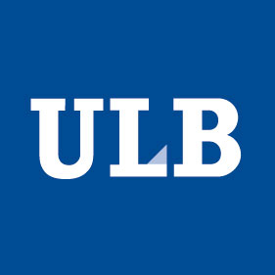 | 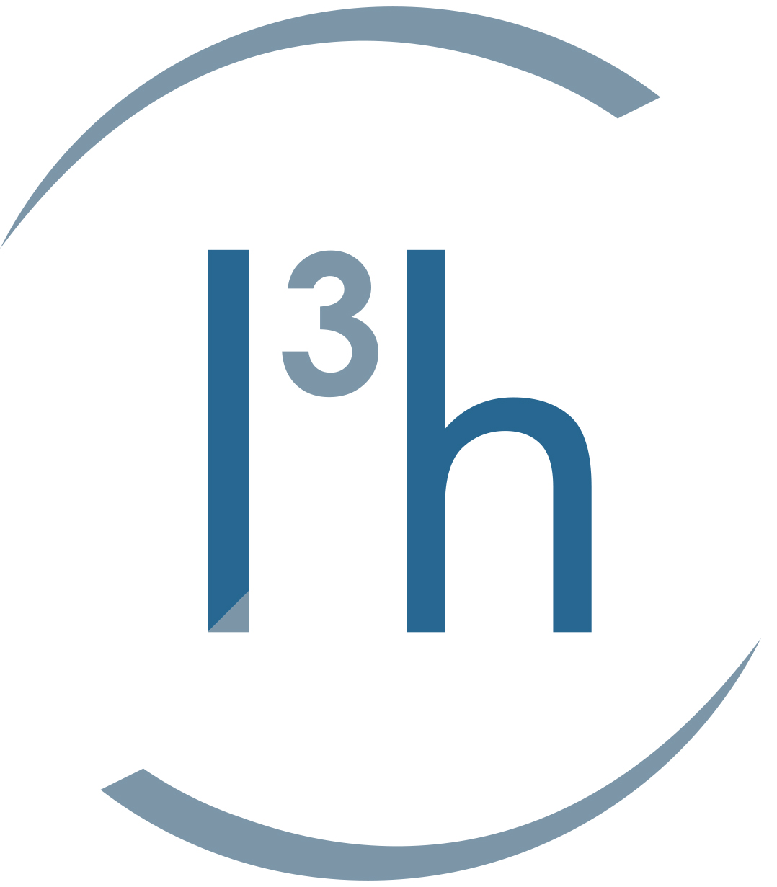 | Université Libre de Bruxelles  CERTIFICATE IN TRANSLATIONAL MEDICINE  Academic year 2015-2016
WEEK 1 TRANSLATIONAL MEDICINE IN PERSPECTIVE Coordinator: M. Goldman

4 January 2016
Introduction to translational medicine
Morning Session : 9h-12h
- Welcome : Marco Schetgen
- Setting the scene : Michel Goldman
- Evidence-based medicine : Christian Melot
- Experimental medicine : Jean-Louis Vincent
Afternoon Session : 14h-17h
- Genomic medicine : Guillaume Smits
- Biomedical engineering : Alain Delchambre & Jacques Devière

5 January 2016
The healthcare landscape
Morning Session : 9h-12h
- Cost-effectiveness in healthcare : Alain Dewever
- Basics of health economics : Mattias Neyt
- Health-technology assessment : Frank Hulstaert
Afternoon Session : 14h-17h
- The multiple steps in drug innovation : Bruno Flamion
- The value chain in drug development : Edouard Croufer

6 January 2016
Pharmacotherapy and other health technologies
Morning Session : 9h-12h
- Pharmacotherapy : Michel Goldman & Bruno Flamion
- Vaccines and prophylaxis against infectious diseases : Pierre Smeesters
- Surgery and robotics : Didier De Cannière
Afternoon Session : 14h-17h
- Medical devices : Jacques Goldstein
- Imaging technologies : Serge Goldman
7 January 2016
Efficacy and safety of health technologies
Morning Session : 9h-12h
- Overview of regulatory approval processes : Greet Musch
- Pharmacovigilance : Nele Maenhout
- Regulation of advanced therapy medicinal products : Claire Beuneu
Afternoon Session : 14h-17h
- The different stages in clinical development of medicines : Michel Toungouz
- The different stages in clinical development of medical devices : Emmanuel Bartholomé
- Strategies towards regulatory approval: Isabelle Huys

8 January 2016
The gateways to business development in healthcare
Morning Session : 9h-12h
- The initial steps in value creation: from intellectual property protection to technology transfer : Cécile Galle & Natalia Kapetanaki (the patenting system)
- Open innovation and IP models for drug innovation Hilde Stevens
- From research to business - New business models in life sciences: Azèle Mathieu
Afternoon Session : 14h-17h
- Public-private partnerships for drug innovation : Hilde Stevens & Magda Papadaki

WEEK 2 BASICS OF PRECLINICAL RESEARCH Coordinator: P. Chatelain

11 January 2016
The pre-clinical phases in biopharmaceutical R&D
Morning Session : 9h-12h
- Introduction : Pierre Chatelain
- Pre-clinical research: value and limits : Jean-Paul Prieels
- In vivo models of disease : Marcelle Van Mechelen
- In vitro models of disease : Antoine Bondue
Afternoon Session : 14h-17h
- Pharmacokinetics and pharmacodynamics : Jean-Marie Nicolas
- Use of human tissues for identification of candidate genes : Décio Eizirik

12 January 2016
Drug Targets
Morning Session : 9h-12h
- Identification and validation of drug targets : Rising importance of genetic dataJean-Marie Boeynaems
- Cancer immunotherapy: Discovery of a novel IDO1 inhibitor : Bruno Comes
Afternoon Session : 14h-17h
- Toxicology : Biopharmaceuticals: Eddy Rommel
- Case study : Marc Parmentier

13 January 2016
Drug Libraries
Morning Session : 9h-12h
- Establishment of drug libraries : Yannick Quesnel
- High throughput screening : Pierre Chatelain
Afternoon Session : 14h-17h
- Case study : Jean-Marie Nicolas

14 January 2016
Project management, knowledge management and risk management in healthcare R&D

Morning Session : 9h-12h
- Project management : Pierre Chatelain
- Risk management : Emmanuel Bartholomé
Afternoon Session : 14h-17h
- Experimental design in preclinical research : Mariana Igoillo-Esteve
- Data collection, data analysis and statistics in preclinical research : Mariana Igoillo-Esteve

15 January 2016
Quality and communication of research results
Morning Session : 9h-12h
- Quality in academic research : Michel Toungouz
- Quality control in clinical biology : Anne Kornreich
- Quality from a regulatory stand-point : Alan Fauconnier
Afternoon Session : 14h-17h
- Scientific communication and writing in life sciences : Cécile Galle
- Master class on tips for publishing research results: Décio Eizirik

WEEK 3 BASICS OF CLINICAL RESEARCH Coordinator: J.-L. Vincent

18 January 2016
Societal and regulatory aspects of clinical investigations
Morning Session : 9h-12h
- Biomedical research: commercial vs. non-commercial trials : Michel Toungouz& Bruno Flamion
- Bioethics and societal aspects : Natalia Kapetanaki
Afternoon Session : 14h-17h
- Overview of clinical trial legislation at EU and national level : Greet Musch
- Regulatory requirements for authorizations of clinical trials: Kristof Bonnarens
- Good clinical practice compliance from a regulatory standpoint : Dominique Delforge

19 January 2016
Designing clinical trials
Morning Session : 9h-12h
- Patient selection and clinical endpoints : Jean-Louis Vincent
- Surrogate markers : Emmanuel Bartholomé
- Collaborative clinical trials : the EORTC model : Françoise Meunier
Afternoon Session : 14h-17h
- Novel trial designs : Christian Melot
- Patient informed consent : Patrick Biston

20 January 2016
Electronic Health Records, Mobile health technologies, Role of Patients
Morning Session : 9h-12h
- Electronical health records: Dipak Kalra
- Mobile health technologies : Pascal Coorevits
- Critical Care : Jacques Creteur
Afternoon Session : 14h-17h
- Global health : Lisa Bonadonna
- The access of patients to innovative medicines: Marc Tomas

21 January 2016
Clinical investigations in cancer and rare diseases
Morning Session : 9h-12h
- Clinical trials in practice: EORTC as a model for cancer research : Sandrine Marreaud
- The role of the surgeon in clinical trials : Vincent Donckier
- The role of patients in drug development : Laure Sonnier
Afternoon Session : 14h-17h
Rare diseases in the development of new medicines
- Repurposing of GLP-1 analogs: from diabetes to neurodegenerative diseases : Miriam Cnop
- Novel targeted therapies for hypereosinophilic disorders : Florence Roufosse

22 January 2016
Special patient populations and biobanks
Morning Session : 9h-12h
- The child under trial : Georges Casimir
- The elderly under trial : Thierry Pepersack
- Big Data in Medicine : Hughues Bersini
Afternoon Session : 14h -17h
- Biobanks : Isabelle Huys
- Data privacy and data protection : Isabelle Huys & Guillaume Smits

WEEK 4 INTRODUCTION TO ENTREPRENEURSHIP and NEW CAREER PATHS Coordinator Olivier Witmeur

25 January 2016
Introduction to fundamentals of healthcare entrepreneurship
Olivier Witmeur & HeeJung Jung
Morning Session : 9h-12h
- What entrepreneurship is and the entrepreneurship framework: People, Opportunity and Resources
- Building a team and distinguishing role inside new ventures
Afternoon Session : 14h -17h
- What makes a good idea? Market and industry attractiveness
- Mapping the ecosystem. Who are the key stakeholders in the new venture creation process?

26 January 2016
From research to business, the journey from IP to company
Olivier Belenger & Florian Taübe
Morning Session : 9h-12h
- New venture incubation
- The business plan
Afternoon Session : 14h -17h
- Managing for growth: the life cycle of a new venture
- Alliances and partnership negotiation

27 January 2016
Funding healthcare ventures from alchemy to IPO
Olivier Witmeur & Alain Parthoens
Morning Session : 9h-12h
- The basics of venture capital
- Grants, business angels and early stage venture capital (case study)
Afternoon Session : 14h -17h
- Early development venture capital (case study)
- Later stages venture capital and Initial Public Offering (case study)

28 January 2016
The innovation leader, entrepreneurship beyond new venture creation
John Metselaar
Morning Session : 9h-12h
- What Innovation Is/Is Not, and Setting Yourself Up for It
- The Systems to Guide Innovation
Afternoon Session : 14h -17h
- Establishing a Successful Culture of Innovation Deep into Your Organization
- The (New) Role of Leadership in this Culture.

29 January 2016

Evaluation - Debriefing
M. Goldman, JL Vincent, B. Flamion, P. Chatelain, E. Bartholomé, C. Galle

